**Flow of Organization Category Wise Claim registration module screen display**

1. **Creation of Organization** : User will create organization for below mention organization category
   1. Bus
   2. Train
   3. Taxi
   4. Private Cars
   5. Private Bus
   6. Rented Vehicles

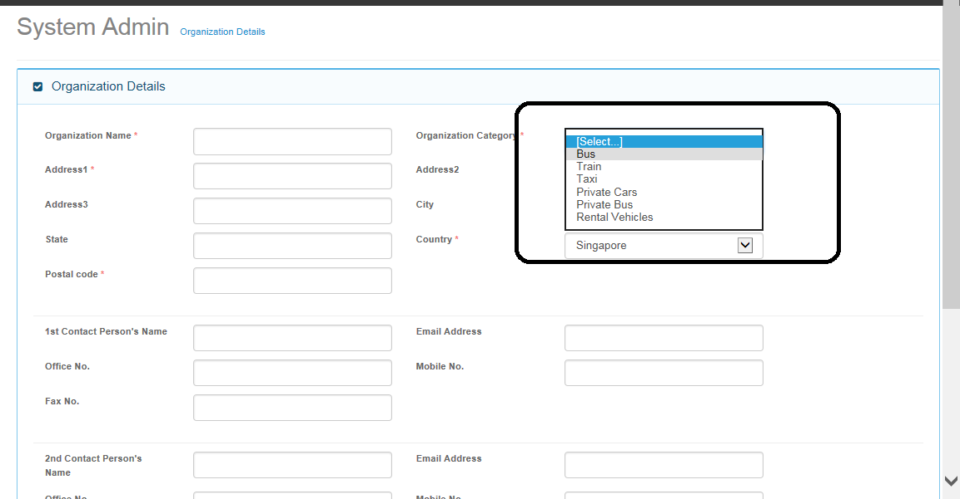

1. **Assigning Organization to User:** 
   1. On User Admin module, created organization will be assigned to user.
   2. On User Details Tab Screen, First user will choose country and then list of organization which is created under selected country will be displayed on organization access tab screen in user admin module. ( Not Yet implemented , Can we add drop down list on user details screen for country , which will have values from Country master ?)

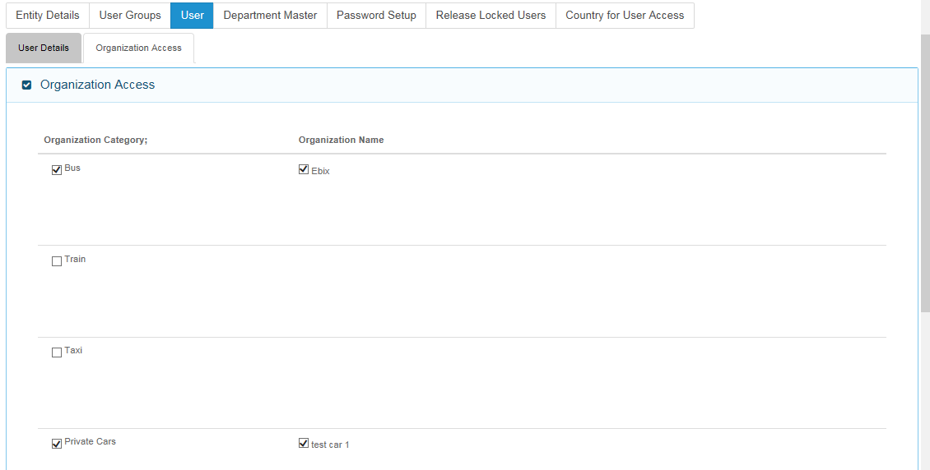

Dexter – 03 Feb 2015:

Yes, this is a good suggestion.

1. **New Claim registration Module :**
   1. On Accident screen, List of Organization will be displayed which is assigned to logged in user.
   2. Based on Select Organization’s Category, all other screens will be displayed. ( Asai needs to provide details of all screen’s fields changes based on organization category)

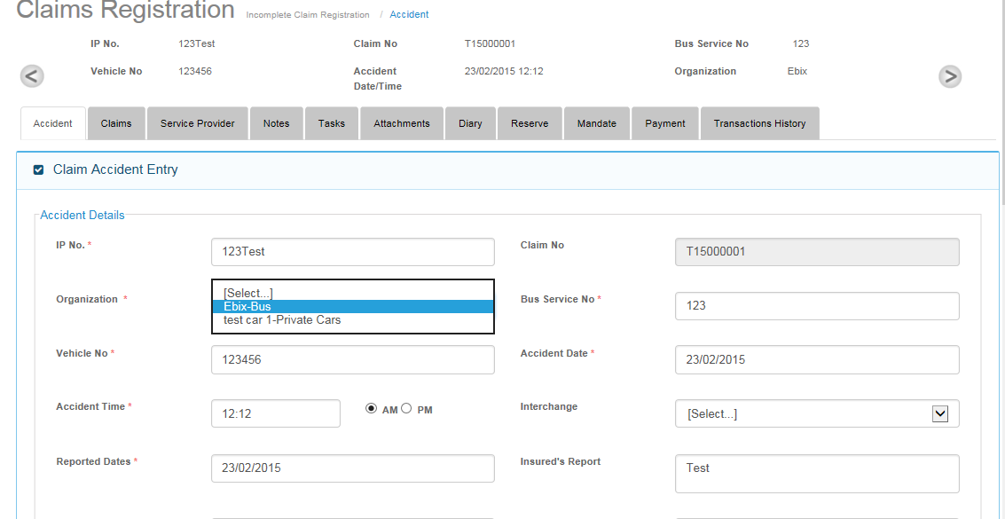

Dexter – 03 Feb 2015:

1. Please kindly confirm that this screen will only be made available on the New Claims Registration.

This is because the flow is that any manual claims creation (or known as Unreported Claims) will only be done on New Claim Registration Section. After user has saved, this manual claim will flow to the Incomplete Claims Registrations if the user did not click on Complete Button.

Uploaded Claims from SAP and TAC will be presented in the Incomplete Claims Registration.

2. How will the user link Manual Claims (or known as Unreported Claims) to Reported Claims?

3. As mentioned in the Project Status File and also during conference call that Aasai will no longer be providing the screen fields for the rest of the organization categories.

Please refer to Pte Car Draft Sample Screens 11-11-14.pdf for the screen fields needed for the rest of the organization. Your team can proceed to implement the screen fields as well.

Also note that Taxi will have 80% similarities and we are waiting for CDGI to come back to us with the screens marked out for changes.